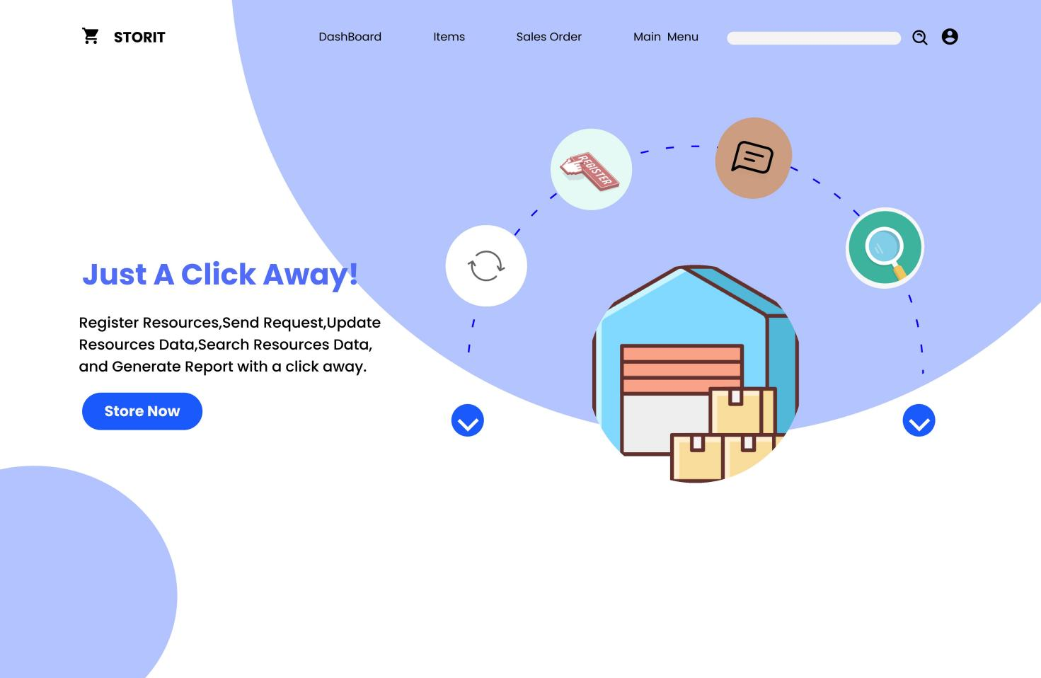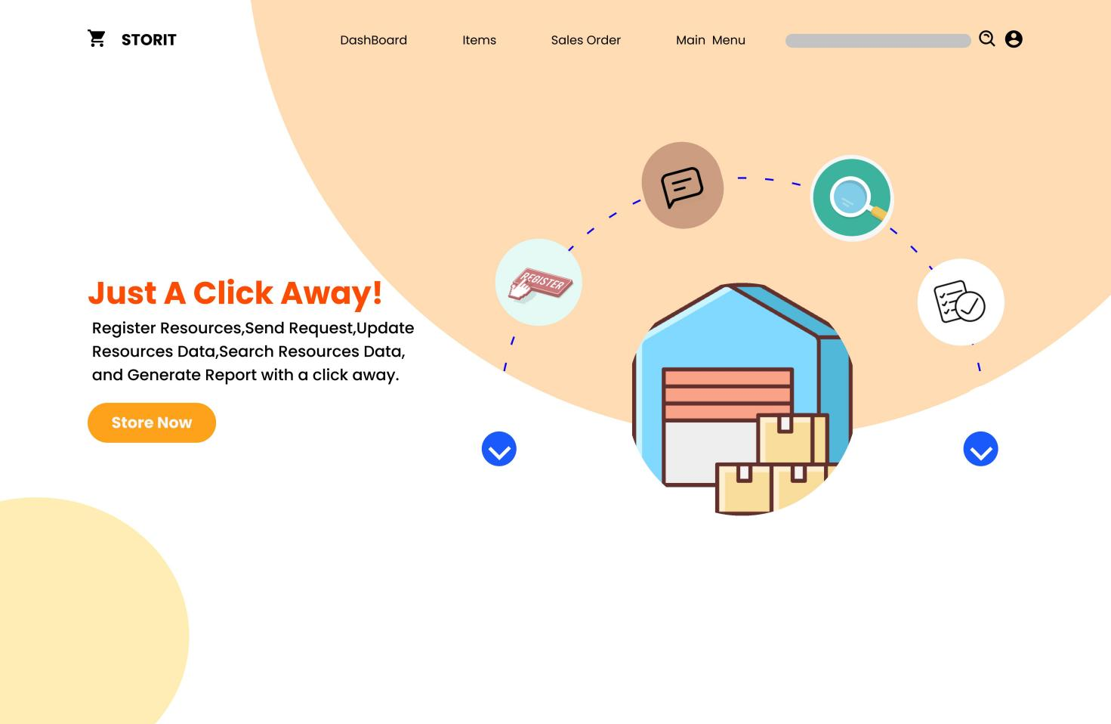

**Store Management System**

Our Website “Storit” Which is short for store-it is a system design to lessen the drawbacks created due to manual store management system.This drawbacks could include:Loss of Items and materials record files,Lack of communication and many many more.

**The specific objectives of our project are:-**

* Register resources:-The proposed system registers all the resources that are entered to

the organization.

* Send request:-the request sent from customer??to get any service from the store.
* Update Resources Data: It updates the resource information when needed.
* Search resource Data: To search resource data within short period of time.
* Generate report: To generate monthly as well as yearly report

**Proposed Website’s Requirements**

**Non-functional Requirements and Constraints**

▪

* User interface: the system provides user interfaces that are compatible with windows

platform.

* Hardware consideration:-the organization should have computers having typical storage

capacity and processing speed.

* Error handling: our website handles error by showing the message” invalid input” when

the user inters invalid input.

* Security: the website should have a security privilege that secures the system.
* Availability-The website should be available at times

**Functional Requirements**

1. The system would be able to register the received materials.
2. The website would be also be able to receive request from users.
3. The website would be able to control expire date of equipment, materials and etc.
4. The website would be able to search and update the material information when it is needed.
5. The website would be able to notice when materials are bought
6. Record items and materials when items and materials are received.
7. Change Status of items and materials when items and materials are used.
8. Receive request and reply for the request.
9. The website should generate timely or year report about the allocation of resources.

**▪**

**To roughly describe our website web page by web page**

**Dashboard:**

The dashboard will show

* Various sales activities like how many packages has been delivered or shipped, how many items we have in stoke and e.t.c
* Inventory Summary
* Purchase order
* Sales order
* Report supported by a line graph

**Items:**

This web page is mainly Focused on listing items in stoke using different filters like expiration date,purchase date and so on

**Sales Order:**

this web page will list out sales order based on different filter

**Main Menu:**

This web page will list different functionality of the website like:

* Dashboard
* Items
* Customers
* Sales orders
* Package
* Payments Received/Made
* Returns
* Purchase order
* Bills

Group Name:

Nazrawit Gemechu (DBUR/1738/12)

Melat Solomon (DBUR/1822/12)

Ruth Abiti (DBUR/1873/12)